Assignment 3 - Machine Learning Optimization

Gabriele Frattaroli

In order to evaluate the relative performance of the random restart hill climbing algorithm and the simulated annealing algorithm, I have considered two different specific measurements, the first is the number of iterations that the algorithm took to solve the puzzle, and the second one is the speed. The median of these values was taken considered the skewed distribution of the results, some iterations took considerably more (or less) time or considerably more (or less) moves, hence why the median is shown.

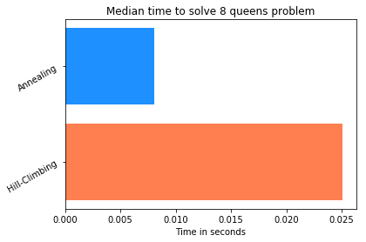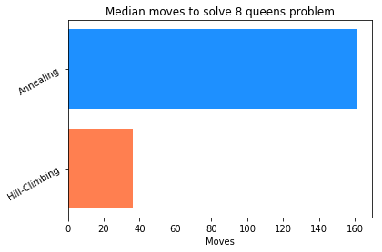

To collect this data, I have taken 50 random iterations of the 8 queens algorithm, stored how long did the algorithm take to finish and how many moves did they take to solve the problem.

For the 8 queens problem, as shown above, the annealing algorithm takes roughly a third of the time of the hill-climbing, while taking about 4 times more moves, however the performances here highlight the clear advantage over time of the Annealing algorithm.

Here below the performances for 25-queens problem:

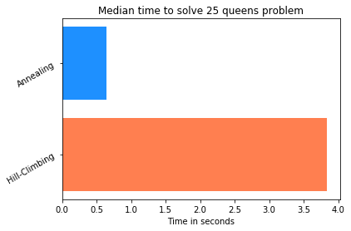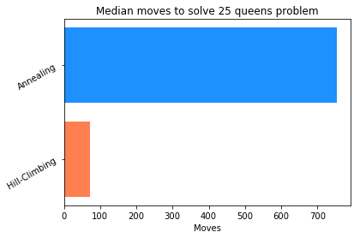

To confirm our previous statement, the Annealing median time to solve a 25 queens problem is much shorter than the Hill-Climbing algorithm, roughly 8 times shorter, while applying almost 10 times more moves.

To show the increase over time I have built a scatterplot that shows the performances of both of the algorithm over time with an increasing number of queens (50 max):

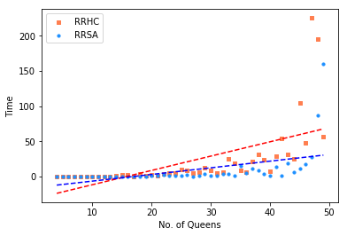

As shown by the graph the Annealing algorithm have a considerable advantage over the hill-climbing algorithm performances considered.